HALF SUBTRACTOR USING NAND GATES

AIM: To implement half subtractor using nand gates through logic sim.

INPUT:

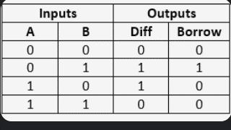

OUTPUT:

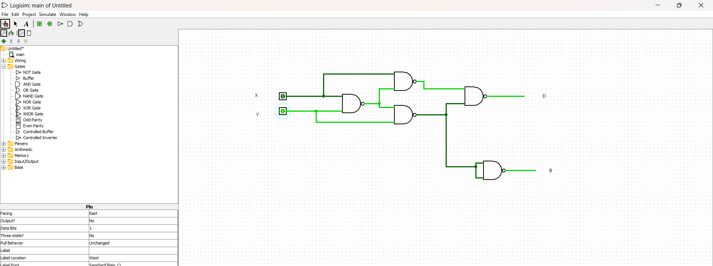

RESULT: Thus the program was executed successfully using logic sim.